**Student Projects Chapter 2 - Applying Planning Techniques to Student Projects**

Read the sample project steps for this chapter and apply the same techniques to the student project that you are developing.

* Step 2.1 - Design the Data Dictionary for Student Projects

Write out a user-oriented data dictionary, consisting of an alphabetical list of every data item referenced in any report or routine transaction, and an informal definition for each term.

|  |
| --- |
| **auditoriumCost:** The cost to rent the theater for the play |
| **contractorCost:** Any expenditures that come from outside contractors |
| **duesAmount:** The amount of money that each patron has paid for dues |
| **duesPaid:** A boolean variable that says whether or not a patron has paid their dues |
| **equipmentCost:** The cost of all the equipment |
| **member:** Amateur actors who produce and perform in productions. |
| **onSiteIncome:** The income that comes as a result of any sales at the play, including food, drinks, and merchandise |
| **otherCosts:** Any cost that occurred that is not included in a previous variable |
| **otherIncome:** Any income that is not included in one of the other income variables |
| **patronAddress:** The address of the patron (not including zip code, town, and state) |
| **patronAreaCode:** The area code of the patron’s phone number |
| **patronCity:** The city the patron lives in |
| **patronEmail:** The email address of the patron |
| **patronFirstName:** The first name of the patron |
| **patronLastName:** The last name of the patron |
| **patronPastPlays:** The List of the the productions the patron bought tickets for in the past. |
| **patronPhoneNumber:** The remaining 7 digits of a patron’s phone number |
| **patronState:** The state the patron lives in |
| **patronZip:** The zip code of the area the patron lives |
| **playlistingAuthor:** The author of the plays that could be produced by the company and will be played for the customers. |
| **playlistingNumberOfActs:** The number of acts during the whole play. |
| **playlistingTitle:** The title of the plays that could be produced by the company and will be played for the customers. |
| **playlistingType:** The type of the plays that could be produced by the company and will be played for the customers such as drama, comedy, musical, etc. |
| **productionCost:** the cost for the production rights. |
| **profitForTheYear:** The profit the group has which is income minus expenditures for the whole year. |
| **programCorporationsNames:** The names of the sponsors to support this program. |
| **programindividualsNames:** The names of the sponsors to support this program. |
| **programMemberJob:** The job of the members they have in this program. |
| **programMemberRole:** The role of the members they are playing in this program. |
| **programMembersNames:** The name of the members in this program. |
| **sponsorIncome:** The income that comes from sponsors. |
| **ticketIncome:** The income that comes as a direct result of ticket sales. |
| **ticketsPlayDate:** the date of the play. |
| **ticketsPlayNames:** The names of the play which will be shown on the tickets. |
| **ticketsPlayTime:** The play time of the plays which will be shown on the tickets. |
| **ticketsPrice:** The price of the tickets. |
| **ticketsSeat:** The seats where the customers will sit will be shown on the tickets. |
| **ticketsSeatNumbers:** The seat numbers which will be shown on the tickets. |
| **totalExpenditures:** The sum of all the cost variables. |
| **totalIncome:** The sum of all the income variables. |

* Step 2.2 - Modify the List of Assumptions as needed.

1. The list of assumptions has no changes at this point. It remains as shown in Step 1.4.

* Step 2.3 - Write out a cross-reference table, showing what data items appear on what forms, reports, or transactions.

To construct the cross-reference table, write the names of all forms, reports, and transactions as column headings across the top of the table. Write the items from the data dictionary down the first column, making a form similar to a spreadsheet. If a data item on a given row appears on a particular form, report, or transaction, place a check mark in the cell for the corresponding column-row intersection.

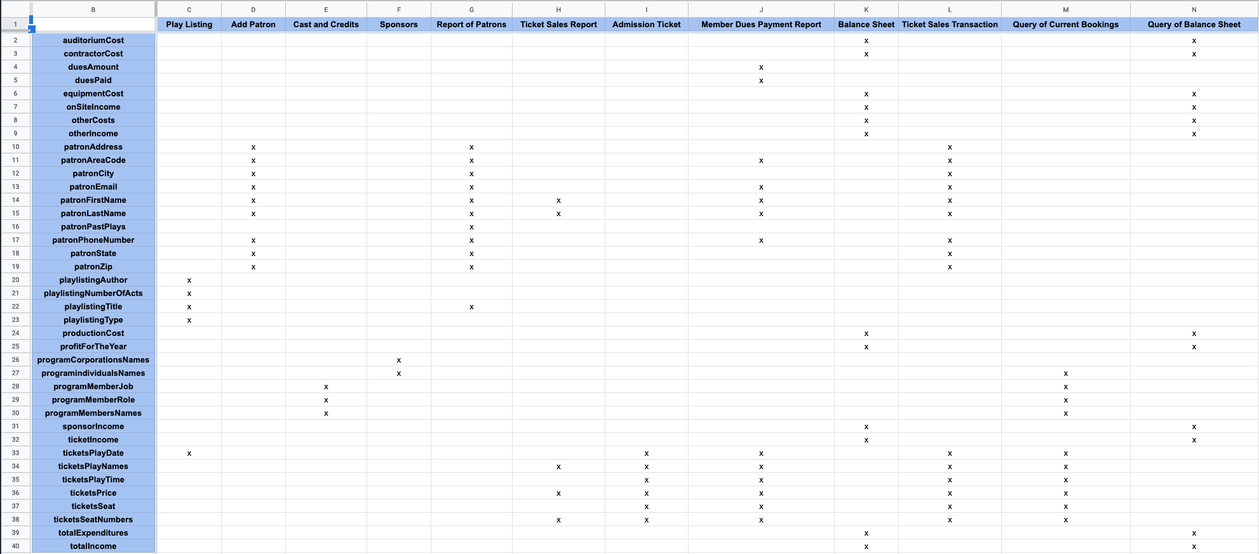

* Step 2.4 - Using a project management tool such as MS Project or a spreadsheet, make a chart that lists the major tasks of the project and assign a timeline for the completion of the entire project. Divide the major tasks into subtasks. If the project is being done by a group, assign the subtasks to the group members. Indicate dependency of one task on another by drawing arrows. Establish deadlines as necessary to complete the project on time.

